Health Care
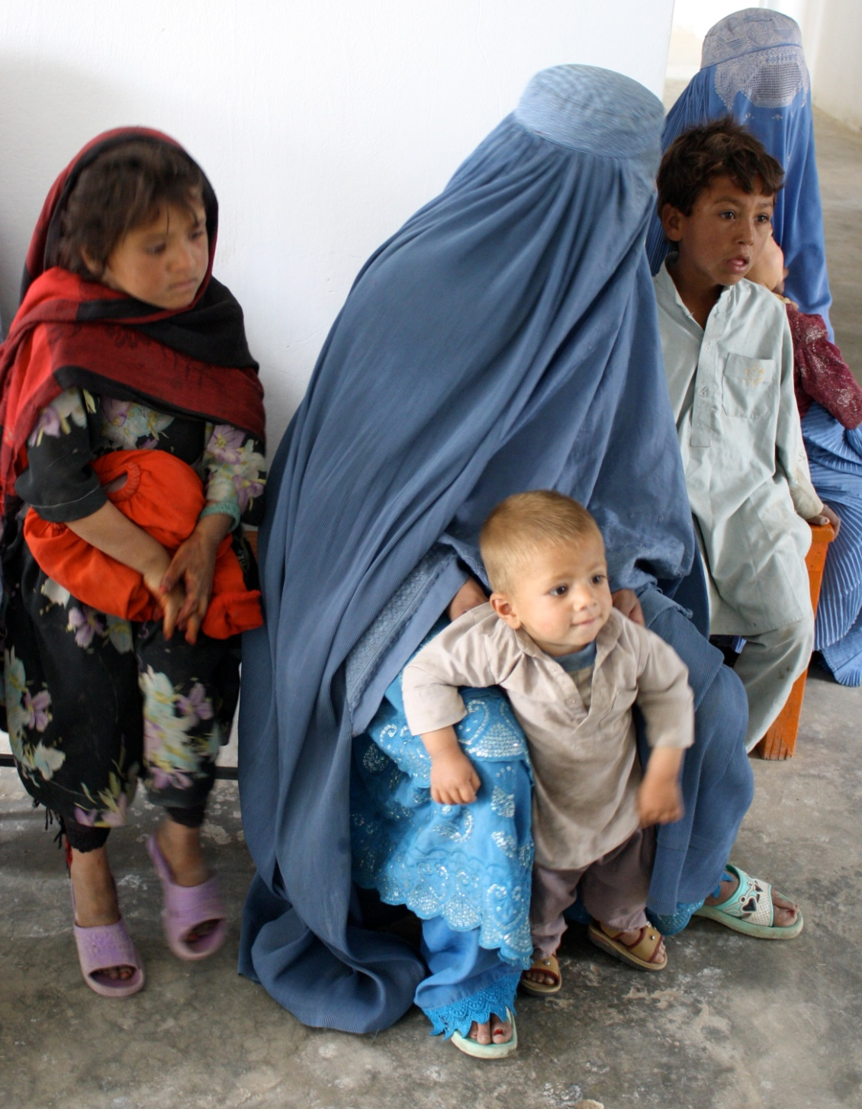
Medical Clinics

Medical Clinics

Who: Afghans who have returned home as refugees, or internally displaced people; and rural villagers with no access to healthcare.

What: Life-saving inoculations, nutrition, and mother and baby care all characterize Sozo’s health offerings. From eradicating a disfiguring skin disease, to helping lower the infant and child mortality rate in Afghanistan through better pre- and post-natal care, Sozo is hard at work on health. In addition, Sozo offers training for volunteers to educate their communities to help prevent disease.

When/Where: Sozo began to bring emergency supplies and to offer health clinics to encampments of refugees in Kabul and to the rural village of Istalif in 2002. In 2004 Sozo began funding two clinics in the rural Shaka Dara region. These clinics reverted to the Ministry of Public Health in 2011. In 2007 Sozo opened a clinic for refugees in Barek Aub. Sozo also operated a clinic in Kabul from 2008-2010, and continues to offer mobile clinics for children, for dental needs, for vision issues, for wheelchair fittings, and other services as needed and available. Sozo works with short-term teams and military volunteers to provide mobile clinics.

Why: Healthcare for rural Afghanistan and refugees is a great need.

How: Sozo provides medicines and services and trains Community Health Workers as volunteers to educate their villages about disease prevention and care, clean water, hygiene, nutrition and family planning.

Learn more at: www.SozoInternational.org
Sozo International, P.O. Box 436967, Louisville, KY 40253
Phone: (502) 253-4308 ● Fax (502) 253-3994
e-mail: info@sozointernational.org

